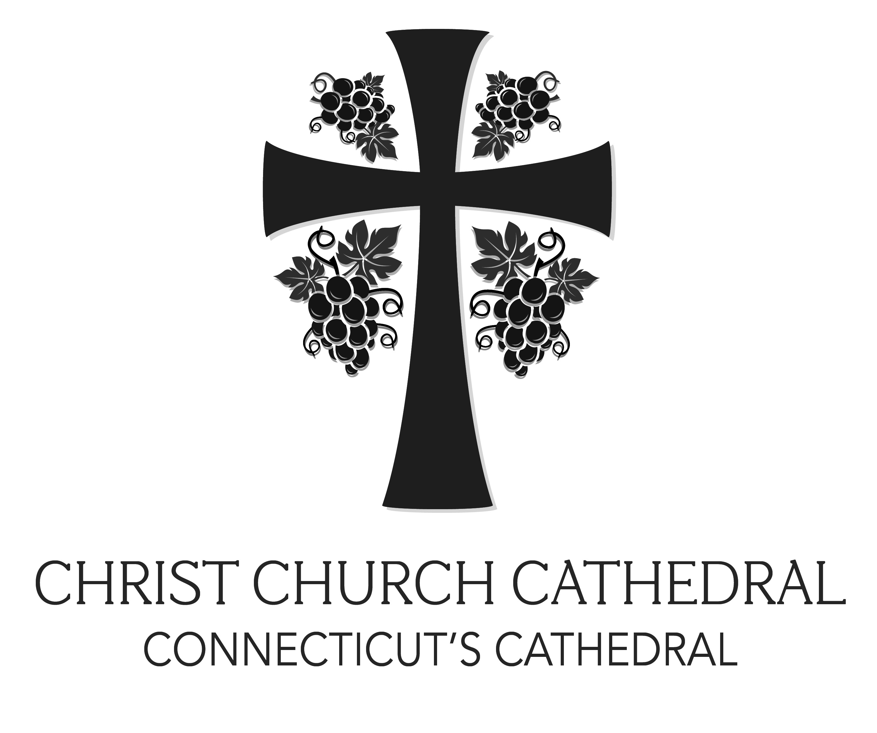

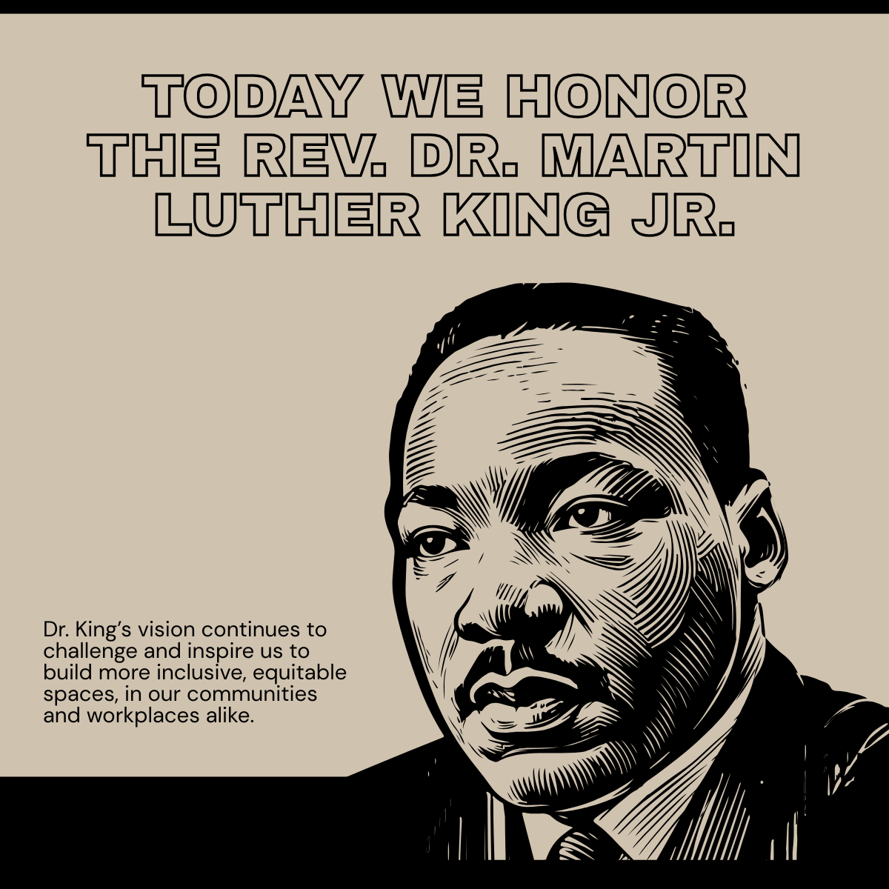
The Second Sunday after Epiphany
Observance of the Rev. Dr. Martin Luther King, Jr.
January 18, 2026
We acknowledge the Tunxis, Sicaog, Wangunks and Poquonook people, the traditional custodians on the land on which Christ Church Cathedral is located. We pay respect to their elders, past and present. We respect their people and traditions as a continued call to live out the ministry of reconciliation to which we are called.
Welcome to our community! Wherever life is taking you, know that we are honored by your presence and invite you to experience God’s life-giving grace with us at Christ Church Cathedral. As a community of faith we celebrate God’s graciousness by proclaiming in word and deed that God’s love is abundant and unconditional. At the Lord’s Table, all baptized are welcome to receive Communion. Please turn off your cell phones once the prelude begins. Should you like to speak with a priest following the service, please contact an usher.
Hymns are in The Hymnal 1982 and Lift Every Voice and Sing II (LEVAS).
At the 8 a.m. service, hymns and the second reading are omitted.
The Gloria is recited at the 8 a.m. service. It can be found on page 356 of the Book of Common Prayer.

The Liturgy of the Word
Prelude ~ Deep River arr. James H. Rogers
Processional Hymn ~ LEVAS II # 62 In Christ there is no east or west
Opening Acclamation
Celebrant Blessed be God: most holy, glorious, and undivided Trinity.
People And blessed be God’s reign, now and forever. Amen.
Almighty God, to you all hearts are open, all desires known, and from you no secrets are hid: Cleanse the thoughts of our hearts by the inspiration of your Holy Spirit, that we may perfectly love you, and worthily magnify your holy Name; through Christ our Lord. Amen.
Gloria ~ LEVAS II # 243 Glory to God Carl Haywood
Collects of the Day
Celebrant God be with you.
People And also with you.
Celebrant Let us pray.
Almighty God, whose Son our Savior Jesus Christ is the light of the world: Grant that your people, illumined by your Word and Sacraments, may shine with the radiance of Christ's glory, that he may be known, worshipped, and obeyed to the ends of the earth; through Jesus Christ our Lord, who with you and the Holy Spirit lives and reigns, one God, now and for ever. Amen..
Almighty God, by the hand of Moses your servant, you led your people out of slavery, and made them free at last: Grant that your Church, following the example of your prophet Martin Luther King, Jr., may resist oppression in the name of your love, and may secure for all your children the blessed liberty of the Gospel of Jesus Christ; who lives and reigns with you and the Holy Spirit, one God, now and for ever. Amen.
Please be seated for the reading of Holy Scripture.
A Reading From ~ Isaiah 49:1-7
Listen to me, O coastlands, pay attention, you peoples from far away! The Lord called me before I was born, while I was in my mother's womb he named me. He made my mouth like a sharp sword, in the shadow of his hand he hid me; he made me a polished arrow, in his quiver he hid me away. And he said to me, “You are my servant, Israel, in whom I will be glorified.” But I said, “I have labored in vain, I have spent my strength for nothing and vanity; yet surely my cause is with the Lord, and my reward with my God.”
And now the Lord says, who formed me in the womb to be his servant, to bring Jacob back to him,
and that Israel might be gathered to him, for I am honored in the sight of the Lord, and my God has become my strength he says, “It is too light a thing that you should be my servant to raise up the tribes of Jacob and to restore the survivors of Israel; I will give you as a light to the nations, that my salvation may reach to the end of the earth.” Thus says the Lord, the Redeemer of Israel and his Holy One, to one deeply despised, abhorred by the nations, the slave of rulers, “Kings shall see and stand up, princes, and they shall prostrate themselves, because of the Lord, who is faithful, the Holy One of Israel, who has chosen you.”

Reader The word of the Lord.
People Thanks be to God.
Psalm 40:1-12 Expectans, expectavi (spoken)
1 I waited patiently upon the Lord; *
he stooped to me and heard my cry.
2 He lifted me out of the desolate pit, out of the mire and clay; *
he set my feet upon a high cliff and made my footing sure.
3 He put a new song in my mouth,
a song of praise to our God; *
many shall see, and stand in awe,
and put their trust in the Lord.
4 Happy are they who trust in the Lord! *
they do not resort to evil spirits or turn to false gods.
5 Great things are they that you have done, O Lord my God!
how great your wonders and your plans for us! *
there is none who can be compared with you.
6 Oh, that I could make them known and tell them! *
but they are more than I can count.
7 In sacrifice and offering you take no pleasure *
(you have given me ears to hear you);
8 Burnt-offering and sin-offering you have not required, *
and so I said, "Behold, I come.
9 In the roll of the book it is written concerning me: *
'I love to do your will, O my God;
your law is deep in my heart.'"
10 I proclaimed righteousness in the great congregation; *
behold, I did not restrain my lips;
and that, O Lord, you know.
11 Your righteousness have I not hidden in my heart;
I have spoken of your faithfulness and your deliverance; *
I have not concealed your love and faithfulness from the great congregation.
12 You are the Lord;
do not withhold your compassion from me; *
let your love and your faithfulness keep me safe for ever.

A Reading From ~ 1 Corinthians 1:1-9
Paul, called to be an apostle of Christ Jesus by the will of God, and our brother Sosthenes,
To the church of God that is in Corinth, to those who are sanctified in Christ Jesus, called to be saints, together with all those who in every place call on the name of our Lord Jesus Christ, both their Lord and ours:
Grace to you and peace from God our Father and the Lord Jesus Christ.
I give thanks to my God always for you because of the grace of God that has been given you in Christ Jesus, for in every way you have been enriched in him, in speech and knowledge of every kind-- just as the testimony of Christ has been strengthened among you-- so that you are not lacking in any spiritual gift as you wait for the revealing of our Lord Jesus Christ. He will also strengthen you to the end, so that you may be blameless on the day of our Lord Jesus Christ. God is faithful; by him you were called into the fellowship of his Son, Jesus Christ our Lord.
Reader The word of the Lord.
People Thanks be to God.

Gradual Hymn ~ LEVAS II # 189 Great is thy faithfulness
The Gospel ~ John 1: 29-42
Deacon The Holy Gospel of our Savior Jesus Christ according to John.
People Glory to you, Lord Christ.
John saw Jesus coming toward him and declared, “Here is the Lamb of God who takes away the sin of the world! This is he of whom I said, ‘After me comes a man who ranks ahead of me because he was before me.’ I myself did not know him; but I came baptizing with water for this reason, that he might be revealed to Israel.” And John testified, “I saw the Spirit descending from heaven like a dove, and it remained on him. I myself did not know him, but the one who sent me to baptize with water said to me, ‘He on whom you see the Spirit descend and remain is the one who baptizes with the Holy Spirit.’ And I myself have seen and have testified that this is the Son of God.”
The next day John again was standing with two of his disciples, and as he watched Jesus walk by, he exclaimed, “Look, here is the Lamb of God!” The two disciples heard him say this, and they followed Jesus. When Jesus turned and saw them following, he said to them, “What are you looking for?” They said to him, “Rabbi” (which translated means Teacher), “where are you staying?” He said to them, “Come and see.” They came and saw where he was staying, and they remained with him that day. It was about four o’clock in the afternoon. One of the two who heard John speak and followed him was Andrew, Simon Peter’s brother. He first found his brother Simon and said to him, “We have found the Messiah” (which is translated Anointed). He brought Simon to Jesus, who looked at him and said, “You are Simon son of John. You are to be called Cephas” (which is translated Peter).

Deacon The Gospel of our Savior.
People Praise to you, Lord Christ.

The Sermon ~ The Rev. Tracy Johnson-Russell, Rector St. Monica’s, Hartford
Following the Sermon, the Celebrant stands. Please stand as you are able.
The Nicene Creed
We believe in one God, the Father, the Almighty,
maker of heaven and earth, of all that is, seen and unseen.
We believe in one Lord, Jesus Christ,
the only Son of God, eternally begotten of the Father,
God from God, Light from Light, true God from true God,
begotten, not made, of one Being with the Father.
Through him all things were made.
For us and for our salvation he came down from heaven,
was incarnate of the Holy Spirit and the Virgin Mary and became truly human.
For our sake he was crucified under Pontius Pilate; he suffered death and was buried.
On the third day he rose again in accordance with the Scriptures;
he ascended into heaven and is seated at the right hand of the Father.
He will come again in glory to judge the living and the dead,
and his kingdom will have no end.
We believe in the Holy Spirit, the Lord, the giver of life, who proceeds from the Father,
who with the Father and the Son is worshiped and glorified,
who has spoken through the prophets.
We believe in one holy catholic and apostolic Church.
We acknowledge one baptism for the forgiveness of sins.
We look for the resurrection of the dead, and the life of the world to come. Amen.

A Prayer for Justice and Reconciliation
For your household with its blessed diversity of races and ethnicities,
We give thanks, O God.
For your presence with those who suffer the pain of oppression because of racism,
We pray, O God.
For the courage and commitment of those who challenge injustice,
We give thanks, O God.
For your forgiveness for our denial and apathy when we have cooperated with powers of dominance and discrimination,
We pray, O God.
For ears to hear stereotyping in church and community, and the courage to name it,
We pray, O God.
For eyes to see exclusion in our lives and churches and for resolve to confront it,
We pray O God.
For minds to address what the conscience knows,
We pray, O God.
For hearts freed of cynicism and despair and renewed with hope,
We pray, O God.
For faith that acts on the certainty of your love for us and on your desire that we honor our differences and live in harmony,
We pray, O God.
For our Ministers, that they may preach the Gospel at all time and seasons and use words when necessary. We pray especially for the Archbishop of Canterbury, Sarah Mullally; We pray for Sean, our Presiding Bishop; Jeff and Laura, our Bishops; Lina, our Dean; Tony, our Canon for Latino Ministry; Bonnie, our Deacon; Dana, Jay, Harlon, Ranjit, D, Kevin, and Rebekah, our Priest Associates; and for our Congregation Committee and Ministry Teams. We also pray for our sister diocese of Aberdeen and Orkney.
We pray, O God.
For those who have asked our prayers: Will, Kathleen R., Connie, Joan Z, MaЇa, Lee, Almeta, Camille, Gerard, Lourdes, Lenora, Ardyce, Mike R., Jennifer, Andrew, Benjamin, Adrianne, Felicity, Sherrod, Graham, Richard, Mark, Bill, Betty Jo, Michael, Jason, Andrew, Jeannie, Denise, Shelly N., Dennis, Charlene, Marcia, Sean, Mary, Diane, Andrew, David, Shaun, Thomas, Alberto, Kelley, Allison, Dina, Aubrey, Bill, Grace, Ben, Frank, Eric, Nelson, Joan, Treviana, Bob, Tyrone, Locksley, Todd, Javon, Debbie, Julian, Rose, Samy, Eugenia, Louis, Sylvia, Anne, Harmony, Cristianne, Joslin, Mary Ellen, Sheila, Priscilla, Guale, Mercy, Deborah, John, Mark C., John, Heather, Susan, Lanny, Grayson, Becky, David M., Nancy, Edgar, Connie, Marcia, Shaun, Goodwin; and for those those we name in our hearts.
We pray, O God.

We pray in fellowship with those from this time and beyond time who have witnessed to your call to community. We covenant with you and each other to be your instruments of justice and reconciliation in this time and in this place. In the name of Christ, who is loving, just, and forgiving, we offer our prayer. Amen.

The Confession of Sin
The Deacon says
Let us confess our sins against God and our neighbor.

Minister and People
Most merciful God, we confess that we have sinned against you in thought, word, and deed,
by what we have done, and by what we have left undone.
We have not loved you with our whole heart;
we have not loved our neighbors as ourselves.
We are truly sorry and we humbly repent.
For the sake of your Son Jesus Christ, have mercy on us and forgive us;
that we may delight in your will, and walk in your ways, to the glory of your Name. Amen.

The Celebrant stands and says
Almighty God have mercy on you, forgive you all your sins through the grace of Jesus Christ, strengthen you in all goodness, and by the power of the Holy Spirit keep you in eternal life. Amen.

The Peace
Celebrant The peace of Christ be always with you.
People And also with you.
The People greet one another in the name of the Lord.
Welcome and Announcements ~ The Very Rev. Miguelina Howell, Cathedral Dean
Dr. Jilda Aliotta, Co-chair Congregations Committee
John Decker, Co-chair, Congregations Committee

Offertory Anthem ~ Wade in the Water arr. Rollo Dilworth
The Doxology ~ LEVAS II # 56 Praise God, from whom all blessings flow

The Holy Communion
The Great Thanksgiving: Enriching Our Worship, Prayer 2
Celebrant The Lord be with you.
People And also with you.
Celebrant Lift up your hearts.
People We lift them to the Lord.
Celebrant Let us give thanks to the Lord our God.
People It is right to give our thanks and praise.
We praise you and we bless you, holy and gracious God, source of life abundant. From before time you made ready the creation. Your Spirit moved over the deep and brought all things into being: sun, moon, and stars; earth, winds, and waters; and every living thing. You made us in your image, and taught us to walk in your ways. But we rebelled against you, and wandered far away; and yet, as a mother cares for her children, you would not forget us. Time and again you called us to live in the fullness of your love.
And so this day we join with Saints and Angels in the chorus of praise that rings through eternity, lifting our voices to magnify you as we sing:
Sanctus ~ LEVAS # 255 Holy, holy, holy Grayson Warren Brown
Glory and honor and praise to you, holy and living God. To deliver us from the power of sin and death and to reveal the riches of your grace, you looked with favor upon Mary, your willing servant, that she might conceive and bear a son, Jesus the holy child of God. Living among us, Jesus loved us. He broke bread with outcasts and sinners, healed the sick, and proclaimed good news to the poor. He yearned to draw all the world to himself yet we were heedless of his call to walk in love. Then, the time came for him to complete upon the cross the sacrifice of his life, and to be glorified by you.
On the night before he died for us, Jesus was at table with his friends. He took bread, gave thanks to you, broke it, and gave it to them, and said: “Take, eat: This is my Body, which is given for you. Do this for the remembrance of me.”
As supper was ending, Jesus took the cup of wine. Again, he gave thanks to you, gave it to them, and said: “Drink this, all of you: This is my Blood of the new Covenant, which is poured out for you and for all for the forgiveness of sins. Whenever you drink it, do this for the remembrance of me.”
Now gathered at your table, O God of all creation, and remembering Christ, crucified and risen, who was and is and is to come, we offer to you our gifts of bread and wine, and ourselves, a living sacrifice.
Pour out your Spirit upon these gifts that they may be the Body and Blood of Christ. Breathe your Spirit over the whole earth and make us your new creation, the Body of Christ given for the world you have made.
In the fullness of time bring us, with all your saints, from every tribe and language and people and nation, to feast at the banquet prepared from the foundation of the world.
Through Christ and with Christ and in Christ, in the unity of the Holy Spirit, to you be honor, glory, and praise, for ever and ever. AMEN.
The Lord’s Prayer
Celebrant And now, as our Savior Christ has taught us, we are bold to say,
Celebrant and People:
Our Father, who art in heaven, hallowed be thy Name,
thy kingdom come, thy will be done, on earth as it is in heaven.
Give us this day our daily bread.
And forgive us our trespasses, as we forgive those who trespass against us.
And lead us not into temptation, but deliver us from evil.
For thine is the kingdom, and the power, and the glory, for ever and ever. Amen.
The Breaking of the Bread
A period of silence is kept.
Celebrant Alleluia! Christ our Passover is sacrificed for us;
People Therefore let us keep the feast. Alleluia!
Agnus Dei ~ LEVAS II # 270 Marjorie Landsmark-DeLewis
Celebrant The Gifts of God for the people of God. Take them in remembrance that Christ died
for you, and feed on him in your hearts by faith, with thanksgiving.
All baptized Christians, regardless of age or denomination, are welcome to receive Holy Communion. When coming forward to receive Holy Communion, please follow the direction given by the ushers. If you are unable to come to the front, please let an usher know and the Sacrament will be brought to you.

Communion Hymn ~ LEVAS II # 136 I have decided to follow Jesus
Prayer after Communion
Eternal God, you have graciously accepted us as living members of our Savior Jesus Christ,
and you have fed us with spiritual food in the Sacrament of his Body and Blood.
Send us now into the world in peace, and grant us strength and courage
to love and serve you with gladness and singleness of heart; through Christ our Savior. Amen.
The Blessing
Recessional Hymn ~ LEVAS # 1 Lift every voice and sing
The Dismissal
Deacon Let us go forth in the name of Christ.
People Thanks be to God.
Postlude ~ Toccata on 'Great Day' by Adolphus Hailstork
__________________________________________________________________________________________________

Music Copyright: Gloria by Carl Haywood, from Mass for Grace, ©1992 Church Music Publishing, all rights reserved. Wade in the water, arr. Rollo Dilworth, ©2014 Hal Leonard Corporation, all rights reserved. Holy, holy, holy by Grayson Warren Brown from A Mass for a Soulful People, ©1974 GW Brown, all rights reserved. Lamb of God by Marjorie Landsmark-DeLewis ©1990 Church Music Publishing, all rights reserved. Toccata on Great Day by Adolphus Hailstork, ©1999 Morningstar Music Publishers, all rights reserved. The music in this service is printed and streamed with permission under ONE LICENSE #A-733705. All rights reserved.
If you are visiting us for the first time, WELCOME! We would like to keep you informed of the amazing blessings we experience in this house of prayer. Please introduce yourself to
Dean Howell, Canon Garcia, or Deacon Matthews.
Following today’s 10:00am service, join us for our annual MLK Luncheon hosted by Church Street Eats. This is an opportunity for our cathedral members and guests of Church Street Eats to gather in community, share a meal, and continue conversations about social justice

SAVE THE DATE

JANUARY

Tuesday, January 20th – Congregation Committee Meeting 6 PM to 8 PM

Wednesday, January 21st -Dean Lina’s Farewell Celebration 6-9PM -Sign up via Eventbrite link
https://www.eventbrite.com/e/an-evening-of-gratitude-in-celebration-of-the-very-rev-miguelina-howell-tickets-1979865770817?aff=oddtdtcreator

Friday, January 23rd – Worship Committee Meeting 2 PM – 3:30 PM in the Reception Room

Sunday, January 25th Dean Lina’s last Worship Service as Cathedral Dean; one bilingual worship service at 9:00 AM only.

FEBRUARY

Sunday, February 1st The Rev. Canon Harlon Dalton begins serving as Christ Church Cathedral’s Interim Dean; Regular Worship services 8AM, 10 AM, and 12:30 PM

Thursday, February 5 – Cathedral Chapter meeting 6 PM in the Cathedral Reception Room.

Dr. King’s vision continues to challenge and inspire us to build more inclusive, equitable spaces, in our communities and workplaces alike. Here are some inspirational quotes by Dr. King that reflect his vision for justice, equality, and love. May they serve as a reminder of the ongoing struggle for civil rights and the importance of love and understanding in overcoming hate and division.

“Darkness cannot drive out darkness; only light can do that. Hate cannot drive out hate; only love can do that.”

“We must learn to live together as brothers or perish as fools.”

“Freedom is never voluntarily given by the oppressor; it must be demanded by the oppressed.”

“Injustice anywhere is a threat to justice everywhere.”

“The ultimate measure of a man is not where he stands in moments of comfort and convenience but where he stands at times of challenge and controversy.”

“I have decided to stick with love. Hate is too great a burden to bear.”

“The time is always right to do what is right.”

CHRIST CHURCH CATHEDRAL
An Episcopal Church within the Anglican Communion
All faithful lay people and clergy of the Episcopal Church in Connecticut
The Rt. Rev. Jeffrey W. Mello, Bishop Diocesan
The Rt. Rev. Laura J. Ahrens, Bishop Suffragan
The Very Rev. Miguelina Howell, Cathedral Dean
The Rev. Ramon Antonio Garcia, Canon for Latino Ministry
The Ven. Bonnie Matthews, Cathedral Deacon
The Rev. Dana Campbell,, The Rev. Dr. Jay Cooke, The Rev. Canon Harlon Dalton, The Rev. Canon Rebekah Hatch, The Rev. Canon Kevin Olds, The Rev. Canon D Littlepage, and The Rev. Canon Ranjit K. Mathews, Priest Associates
Dr. Jilda Aliotta, Chair of Congregation Committee
John Decker, Vice-Chair of Congregation Committee
Since 1762, this Christian community has gathered for worship. To learn more about the ministries
we share in this place, you are invited to speak to the clergy or parishioners after the service.
____________________________________________________________________________________________________________
Serving at 8:00 a.m.

Celebrant & Preacher The Rev. Tracy Johnson-Russell

Assisting The Ven. Bonnie Matthews, Cathedral Deacon

Psalm Leader / Verger John Scott

Intercessor/Altar Server Dr. Jilda Aliotta

Lector Nancy Jacobs
Serving at 10:00 a.m.

Celebrant The Very Rev. Miguelina Howell, Cathedral Dean

Preacher The Rev. Tracy Johnson-Russell, Rector, St. Monica’s, Hartford

Assisting The Rev. Ramon Antonio Garcia, Canon for Latino Ministry

The Rev. Bonnie Matthews, Cathedral Deacon

Vergers Dr. Jilda Aliotta, Marcia Barnett, Peggy Ornell
Crucifer John Scott
Virtual Vergers Richard Baraglia and Deborah Simmons
Digital Evangelist Samuel Hernandez

First Lector John Decker

Second Lector Viola Mullin
Ushers Gilbeean Scott and Vernell Davis
Guild Gilbeean Scott, Sheila Green, David Marcano, and Nagda and Ramon Echavarria
Choir Kelley Kelly, Sarah Marze, Viola Mullin, Scott Patrick, Phoenix Sheerin, Deborah Simmons, Kristen Williams

CATHEDRAL STAFF
David Borawski, Building Manager Pedro Cirilo Coral, Spanish Music Coordinator
Cindy Hursty, Accountant Nelson Mena, Spanish Music Coordinator
John Scott, Sacristan Trish Leonard, Interim Assistant to the Dean
Marianne Vogel, Director of Music Carolina Pujols, Office Manager & Event Coordinator
Christ Church Cathedral / 45 Church Street, Hartford, CT 06103
office@cccathedral.org * www.cccathedral.org * 860-527-7231

